操作用户：root
- 将oracle11g安装包上传至/tmp下
oracle11.2.0.1.0下载地址：
https://www.oracle.com/technetwork/database/enterprise-edition/downloads/112010-linx8664soft-100572.html
- 修改主机名（如果已经不是localhost可跳过此步骤）
编辑vim /etc/hosts文件新增以下行：
#你的IP地址 空格 主机名
192.168.22.1 risen
编辑vim /etc/hostname文件删除原来的并添加：
risen
保存退出，并使之生效执行命令hostname risen
- 修改系统名称：
编辑文件vi /etc/redhat-release修改为：
redhat-7
- 配置yum源本地仓库并安装编译环境***
yum -y install binutils-* compat-libstdc++-* compat-libcap1-* \
elfutils-libelf-* elfutils-libelf-devel-* gcc* gcc-c++-* glibc* \
glibc-common-* glibc-devel-* glibc-headers-* ksh-* \
libaio-* libaio-devel-* libgcc-* libstdc++-* libstdc++-devel* make-* \
sysstat-* unixODBC-* unixODBC-devel-* numactl-devel-* pdksh-* \
kernel-headers*
- JDK1.7配置
查看JDK安装文档，这里不再阐述
- 创建oinstall用户组和dba用户组以及oracle用户
groupadd oinstall
groupadd dba
useradd -g oinstall -G dba oracle
为oracle用户设置密码：
echo "oracle" | passwd --stdin oracle
- 修改用户环境变量
编辑/home/oracle/.bash_profile文件，新增以下内容：
umask 022
stty erase ^H
PATH=$PATH:$HOME/bin
TMP=/tmp
TMPDIR=$TMP
ORACLE_BASE=/home/oracle/app/oracle
ORACLE_HOME=$ORACLE_BASE/product/11.2.0/db_1
ORACLE_SID=orcl
ORACLE_TERM=xterm
PATH=$PATH:$HOME/bin:$ORACLE_HOME/bin
LD_LIBRARY_PATH=$ORACLE_HOME/lib:/lib:/usr/lib
CLASSPATH=$ORACLE_HOME/JRE:$ORACLE_HOME/jlib:$ORACLE_HOME/rdbms/jlib
NLS_DATE_FORMAT="yyyy-mm-dd HH24:MI:SS"
NLS_LANG=AMERICAN_AMERICA.ZHS16GBK
export EDITOR=vi
export TMP TMPDIR ORACLE_TERM CLASSPATH NLS_DATE_FORMAT ORACLE_BASE ORACLE_HOME ORACLE_SID PATH LD_LIBRARY_PATH NLS_LANG EDITOR
- 进入到/tmp目录下解压oracle11g的压缩包
unzip linux.x64_11gR2_database_1of2.zip
unzip linux.x64_11gR2_database_2of2.zip
- 修改解压后的oracle目录权限
chmod -R 777 /tmp/database
chown -R oracle.oinstall /tmp/database
- 创建app目录：
mkdir -p /home/oracle/app/oracle
并编辑/etc/oraInst.loc文件，并新增
nventory_loc=/home/oracle/app/oracle_oraInventory
inst_group=oinstall
修改oralnst.loc权限：
chown oracle:oinstall /etc/oraInst.loc
chmod 664 /etc/oraInst.loc
- 在/home/oracle/目录下新建目录etc并执行以下命令：
mkdir /home/oracle/etc
cp /tmp/database/response/* /home/oracle/etc/
- 修改系统限制文件
对于系统重要文件我们需要提前备份一份，执行命令：
cp /etc/security/limits.conf /etc/security/limits.conf.bak
然后编辑/etc/security/limits.conf文件在文件末尾加上以下设置：（如果已经存在则跳过此步骤）
oracle soft nofile 1024
oracle hard nofile 65536
grid soft nproc 2047
grid hard nproc 16384
grid soft nofile 1024
grid hard nofile 65536
- 设置重启机器开始生效
对于系统重要文件我们需要提前备份一份，执行命令：
cp /etc/pam.d/login /etc/pam.d/login.bak
然后编辑/etc/pam.d/login文件在文件末尾加上以下配置：（如果已经存在则跳过此步骤）
#session required /lib/security/pam_limits.so
session required pam_limits.so
- 设置系统环境变量
对于系统重要文件我们需要提前备份一份，执行命令：
cp /etc/profile /etc/profile.bak
然后编辑/etc/profile文件在文件末尾加上以下配置：（如果已经存在则跳过此步骤）
if [ $USER = "oracle" ]; then
if [ $SHELL = "/bin/ksh" ]; then
ulimit -p 16384
ulimit -n 65536
else
ulimit -u 16384 -n 65536
fi
fi
使环境变量生效：
source /etc/profile
- 设置系统参数文件
对于系统重要文件我们需要提前备份一份，执行命令：
cp /etc/sysctl.conf /etc/sysctl.conf.bak
然后编辑/etc/sysctl.conf文件并在文件末尾加上以下配置：（如果已经存在则跳过此步骤）
fs.aio-max-nr = 1048576
fs.file-max = 6815744
kernel.shmall = 2097152
kernel.shmmax = 1054472192
kernel.shmmni = 4096
kernel.sem = 250 32000 100 128
net.ipv4.ip_local_port_range = 9000 65500
net.core.rmem_default = 262144
net.core.rmem_max = 4194304
net.core.wmem_default = 262144
net.core.wmem_max = 1048586
net.ipv4.tcp_wmem = 262144 262144 262144
net.ipv4.tcp_rmem = 4194304 4194304 4194304
然后执行sysctl -p命令使其生效
- 修改目录权限以及目录用户权限
chmod -R 777 /home/oracle/app/oracle
chown -R oracle.oinstall /home/oracle
操作用户：oracle
- 配置oracle安装文件
进入到/home/oracle/etc目录下，编辑db_install.rsp文件：
oracle.install.responseFileVersion=/oracle/install/rspfmt_dbinstall_response_schema_v11_2_0
oracle.install.option=INSTALL_DB_SWONLY
ORACLE_HOSTNAME=risen
UNIX_GROUP_NAME=oinstall
INVENTORY_LOCATION=/home/oracle/app/oracle_oraInventory
SELECTED_LANGUAGES=en,zh_CN
ORACLE_HOME=/home/oracle/app/oracle/product/11.2.0/db_1
ORACLE_BASE=/home/oracle/app/oracle_base
oracle.install.db.InstallEdition=EE
oracle.install.db.isCustomInstall=true
oracle.install.db.DBA_GROUP=dba
oracle.install.db.OPER_GROUP=oinstall
oracle.install.db.config.starterdb.type=GENERAL_PURPOSE
oracle.install.db.config.starterdb.globalDBName=orcl
oracle.install.db.config.starterdb.SID=orcl
oracle.install.db.config.starterdb.characterSet=ZHS16GBK
oracle.install.db.config.starterdb.memoryOption=true
oracle.install.db.config.starterdb.memoryLimit=512
oracle.install.db.config.starterdb.installExampleSchemas=false
oracle.install.db.config.starterdb.enableSecuritySettings=true
oracle.install.db.config.starterdb.password.ALL=123456
DECLINE_SECURITY_UPDATES=true
- 开始安装
进入到/tmp/database目录下执行以下命令：
./runInstaller -silent -ignorePrereq -responseFile /home/oracle/etc/db_install.rsp
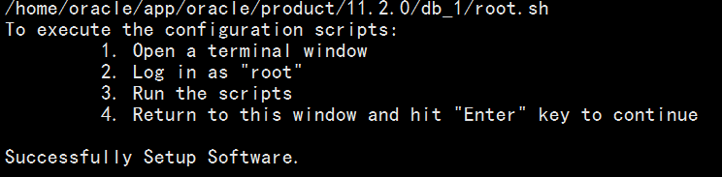
需要等一会。若果没有问题，则继续下一步，如果有问题，查看相应的日志去解决，
出现Successfully Setup Software.信息则说明安装成功。
- 切换至root用户执行以下命令
sh /home/oracle/app/oracle/product/11.2.0/db_1/root.sh
- 静默配置监听切换至oracle用户
完成之前步骤说明oracle的基本命令已经安装，并且在最开始我们已经将oracle的安装目录中的命令配置到了环境变量中，现在只需要使环境变量生效执行命令：
source /home/oracle/.bash_profile
然后开始安装监听：
netca /silent /responsefile /home/oracle/etc/netca.rsp
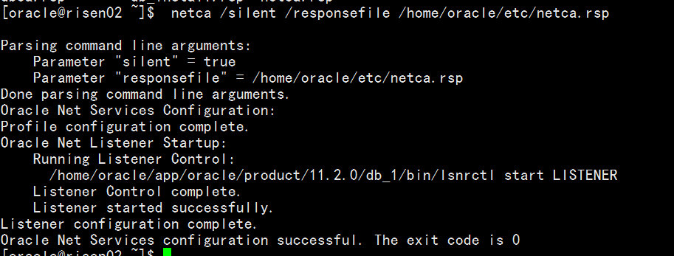
此处可能会报错命令解析错误，需要手动写入此命令，不然直接复制可能带有其它隐藏特殊字符。
通过查看端口命令查看1521端口是否启动
- 静默安装库
修改dbca.rsp文件： /home/oracle/app/oracle/product/11.2.0/db_1/assistants/dbca/
#数据库名.主机名
GDBNAME = "orcl.risen"
#设置实例名
SID = "orcl"
TEMPLATENAME = "General_Purpose.dbc"
#设置sys账户密码
SYSPASSWORD = "123456"
#设置system账户密码
SYSTEMPASSWORD = "123456"
DATAFILEDESTINATION = /home/oracle/app/oracle/oradata
RECOVERYAREADESTINATION= /home/oracle/app/oracle/oradata_back
CHARACTERSET = "ZHS16GBK"
TOTALMEMORY = "512"
执行命令:
export DISPLAY=0.0
dbca -silent -responsefile /home/oracle/etc/dbca.rsp
不要复制最好手动写，不然可能夹杂其它特殊字符。
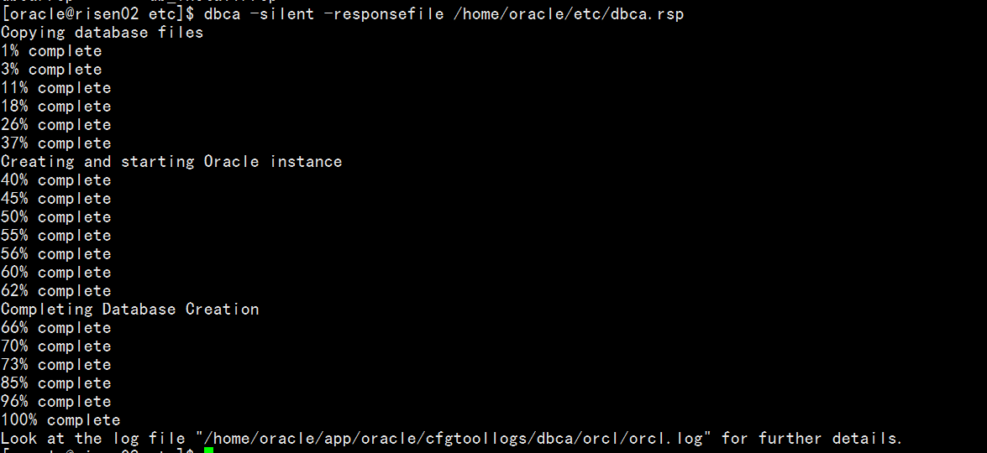
- 查看监听状态
执行命令：lsnrctl status
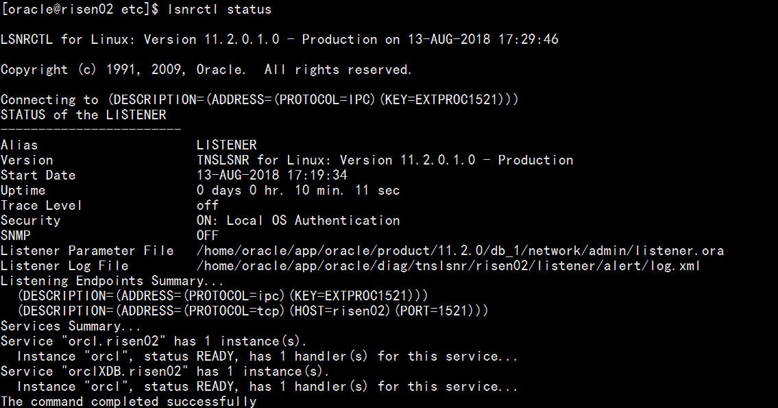
配置监听文件执行命令：
cp /home/oracle/app/oracle/product/11.2.0/db_1/network/admin/samples/tnsnames.ora /home/oracle/app/oracle/product/11.2.0/db_1/network/admin/

cp /home/oracle/app/oracle/product/11.2.0/db_1/network/admin/samples/listener.ora /home/oracle/app/oracle/product/11.2.0/db_1/network/admin/

然后进入到
/home/oracle/app/oracle/product/11.2.0/db_1/network/admin/
目录下进行编辑tnsnames.ora在文件末尾新增：
orcl=
(DESCRIPTION =
(ADDRESS_LIST =
(ADDRESS = (PROTOCOL = TCP)(HOST = 192.168.22.1)(PORT = 1521))
)
(CONNECT_DATA =
(SERVICE_NAME = orcl)
)
)
保存并退出
然后编辑listener.ora文件
LISTENER =
(ADDRESS_LIST=
(ADDRESS=(PROTOCOL=tcp)(HOST=192.168.22.1)(PORT=1521))
(ADDRESS=(PROTOCOL=ipc)(KEY=PNPKEY)))

SID_LIST_LISTENER=
(SID_LIST=
(SID_DESC=
(GLOBAL_DBNAME=orcl)
(SID_NAME=orcl)
(ORACLE_HOME=/home/oracle/app/oracle/product/11.2.0/db_1)
(PRESPAWN_MAX=20)
(PRESPAWN_LIST=
(PRESPAWN_DESC=(PROTOCOL=tcp)(POOL_SIZE=2)(TIMEOUT=1))
)
)
)
保存并退出。然后重启监听，执行命令：
lsnrctl stop
lsnrctl start
查看一下监听状态：
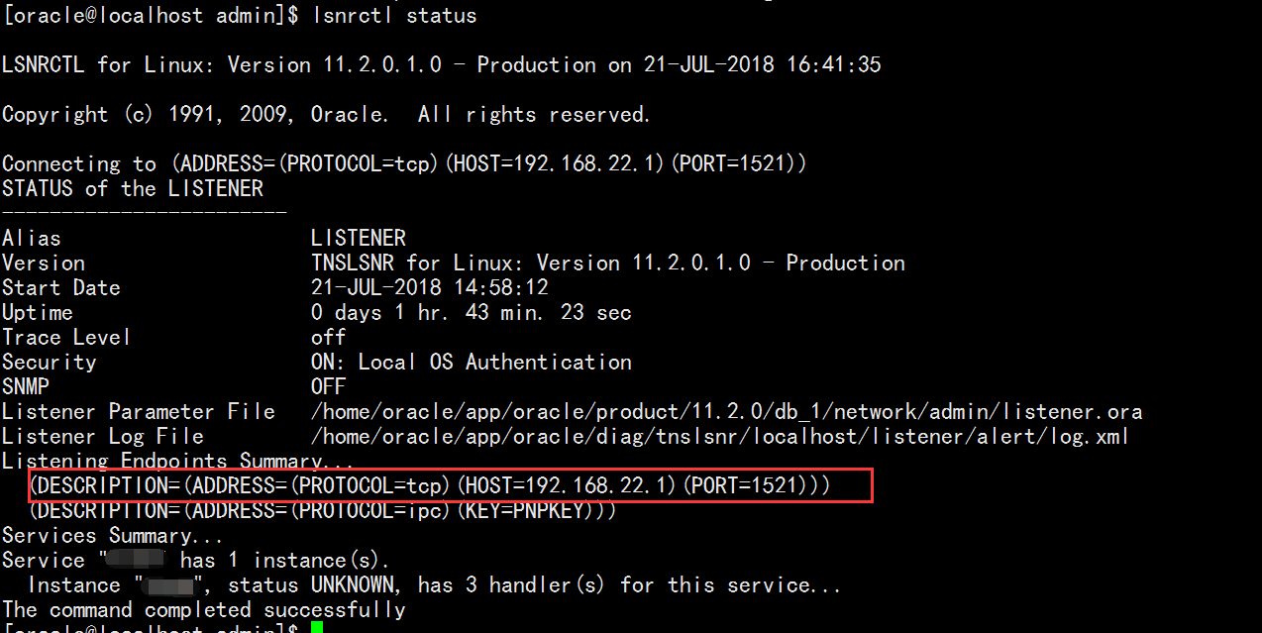
- 启动oracle
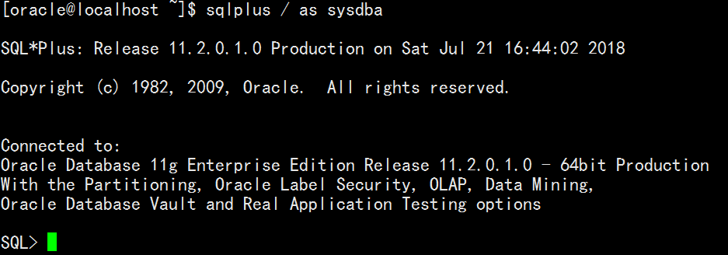
登录后执行命令：startup
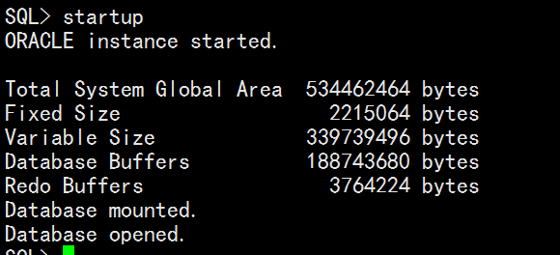
说明启动成功，到此所有安装完成。可以新建一个用户然后通过Windows客户端去访问一下。

ORA-00845: MEMORY_TARGET not supported on this system问题处理
https://blog.csdn.net/abcaxyzx/article/details/20747233

问题汇总：
问题一：
报错缺少DISPLAY变量
解决一：在当前窗口执行export DISPLAY=0.0
问题二：
lsnrctl: error while loading shared libraries: /u01/app/oracle/product/11.2.0/db_1/lib/libclntsh.so.11.1: cannot restore segment prot after reloc: Permission denied
解决二：
在root用户下执行以下命令
su - root
setenforce 0
附件：
db_install.rsp详解
####################################################################
## Copyright(c) Oracle Corporation1998,2008. All rights reserved. ##
## Specify values for the variables listedbelow to customize your installation. ##
## Each variable is associated with acomment. The comment ##
## can help to populate the variables withthe appropriate values. ##
## IMPORTANT NOTE: This file contains plaintext passwords and ##
## should be secured to have readpermission only by oracle user ##
## or db administrator who owns thisinstallation. ##
##对整个文件的说明，该文件包含参数说明，静默文件中密码信息的保密 ##
####################################################################
#------------------------------------------------------------------------------
# Do not change the following system generatedvalue. 标注响应文件版本，这个版本必须和要#安装的数据库版本相同，安装检验无法通过,不能更改
#------------------------------------------------------------------------------
oracle.install.responseFileVersion=/oracle/install/rspfmt_dbinstall_response_schema_v11_2_0
#------------------------------------------------------------------------------
# Specify the installation option.
# It can be one of the following:
# 1. INSTALL_DB_SWONLY
# 2. INSTALL_DB_AND_CONFIG
# 3. UPGRADE_DB
#选择安装类型：1.只装数据库软件 2.安装数据库软件并建库 3.升级数据库
#-------------------------------------------------------------------------------
oracle.install.option=INSTALL_DB_SWONLY
#-------------------------------------------------------------------------------
# Specify the hostname of the system as setduring the install. It can be used
# to force the installation to use analternative hostname rather than using the
# first hostname found on the system.(e.g., for systems with multiple hostnames
# and network interfaces)指定操作系统主机名，通过hostname命令获得
#-------------------------------------------------------------------------------
ORACLE_HOSTNAME=ora11gr2
#-------------------------------------------------------------------------------
# Specify the Unix group to be set for theinventory directory.
#指定oracle inventory目录的所有者，通常会是oinstall或者dba
#-------------------------------------------------------------------------------
UNIX_GROUP_NAME=oinstall
#-------------------------------------------------------------------------------
# Specify the location which holds theinventory files.
#指定产品清单oracle inventory目录的路径,如果是Win平台下可以省略
#-------------------------------------------------------------------------------
INVENTORY_LOCATION=/u01/app/oracle/oraInventory
#-------------------------------------------------------------------------------
# Specify the languages in which thecomponents will be installed.
# en : English ja : Japanese
# fr : French ko : Korean
# ar : Arabic es : Latin American Spanish
# bn : Bengali lv : Latvian
# pt_BR: Brazilian Portuguese lt : Lithuanian
# bg : Bulgarian ms : Malay
# fr_CA: Canadian French es_MX: Mexican Spanish
# ca : Catalan no : Norwegian
# hr : Croatian pl : Polish
# cs : Czech pt : Portuguese
# da : Danish ro : Romanian
# nl : Dutch ru : Russian
# ar_EG: Egyptian zh_CN: Simplified Chinese
# en_GB: English (Great Britain) sk :Slovak
# et : Estonian sl : Slovenian
# fi : Finnish es_ES: Spanish
# de : German sv : Swedish
# el : Greek th : Thai
# iw : Hebrew zh_TW:Traditional Chinese
# hu : Hungarian tr : Turkish
# is : Icelandic uk : Ukrainian
# in : Indonesian vi :Vietnamese
# it : Italian
# Example : SELECTED_LANGUAGES=en,fr,ja
#指定数据库语言，可以选择多个，用逗号隔开。选择en, zh_CN(英文和简体中文)
#------------------------------------------------------------------------------
SELECTED_LANGUAGES=en,zh_CN
#------------------------------------------------------------------------------
# Specify the complete path of the OracleHome.设置ORALCE_HOME的路径
#------------------------------------------------------------------------------
ORACLE_HOME=/u01/app/oracle/product/11.2.0/db_1
#------------------------------------------------------------------------------
# Specify the complete path of the OracleBase. 设置ORALCE_BASE的路径
#------------------------------------------------------------------------------
ORACLE_BASE=/u01/app/oracle
#------------------------------------------------------------------------------
# Specify the installation edition of thecomponent.
# The value should contain only one ofthese choices.
# EE : EnterpriseEdition
# SE : Standard Edition
# SEONE Standard Edition One
# PE : Personal Edition (WINDOWS ONLY)
#选择Oracle安装数据库软件的版本（企业版，标准版，标准版1），不同的版本功能不同
#详细的版本区别参考附录D
#------------------------------------------------------------------------------
oracle.install.db.InstallEdition=EE
#------------------------------------------------------------------------------
# This variable is used to enable ordisable custom install.
# true : Components mentioned as part of 'customComponents' property
#are considered for install.
# false : Value for 'customComponents' isnot considered.
#是否自定义Oracle的组件，如果选择false，则会使用默认的组件
#如果选择true否则需要自己在下面一条参数将要安装的组件一一列出。
#安装相应版权后会安装所有的组件，后期如果缺乏某个组件，再次安装会非常的麻烦。
#------------------------------------------------------------------------------
oracle.install.db.isCustomInstall=true
#------------------------------------------------------------------------------
# This variable is considered only if'IsCustomInstall' is set to true.
# Description: List of Enterprise EditionOptions you would like to install.
# The following choices areavailable. You may specify any
# combination of thesechoices. The components you chooseshould
# be specified in the form"internal-component-name:version"
# Below is a list of components youmay specify to install.
# oracle.rdbms.partitioning:11.2.0.1.0- Oracle Partitioning
# oracle.rdbms.dm:11.2.0.1.0- Oracle Data Mining
# oracle.rdbms.dv:11.2.0.1.0- Oracle Database Vault
# oracle.rdbms.lbac:11.2.0.1.0- Oracle Label Security
# oracle.rdbms.rat:11.2.0.1.0- Oracle Real Application Testing
# oracle.oraolap:11.2.0.1.0- Oracle OLAP
# oracle.install.db.isCustomInstall=true的话必须手工选择需要安装组件的话
#------------------------------------------------------------------------------
oracle.install.db.customComponents=oracle.server:11.2.0.1.0,oracle.sysman.ccr:10.2.7.0.0,oracle.xdk:11.2.0.1.0,oracle.rdbms.oci:11.2.0.1.0,oracle.network:11.2.0.1.0,oracle.network.listener:11.2.0.1.0,oracle.rdbms:11.2.0.1.0,oracle.options:11.2.0.1.0,oracle.rdbms.partitioning:11.2.0.1.0,oracle.oraolap:11.2.0.1.0,oracle.rdbms.dm:11.2.0.1.0,oracle.rdbms.dv:11.2.0.1.0,orcle.rdbms.lbac:11.2.0.1.0,oracle.rdbms.rat:11.2.0.1.0
###############################################################################
# PRIVILEGED OPERATING SYSTEM GROUPS
# Provide values for the OS groups to whichOSDBA and OSOPER privileges #
# needs to be granted. If the install isbeing performed as a member of the #
# group "dba", then that will beused unless specified otherwise below. #
#指定拥有OSDBA、OSOPER权限的用户组，通常会是dba组
###############################################################################
#------------------------------------------------------------------------------
# The DBA_GROUP is the OS group which is tobe granted OSDBA privileges.
#------------------------------------------------------------------------------
oracle.install.db.DBA_GROUP=dba
#------------------------------------------------------------------------------
# The OPER_GROUP is the OS group which isto be granted OSOPER privileges.
#------------------------------------------------------------------------------
oracle.install.db.OPER_GROUP=oinstall
#------------------------------------------------------------------------------
# Specify the cluster node names selectedduring the installation.
#如果是RAC的安装，在这里指定所有的节点
#------------------------------------------------------------------------------
oracle.install.db.CLUSTER_NODES=
#------------------------------------------------------------------------------
# Specify the type of database to create.
# It can be one of the following:
# - GENERAL_PURPOSE/TRANSACTION_PROCESSING
# - DATA_WAREHOUSE
#选择数据库的用途，一般用途/事物处理，数据仓库
#------------------------------------------------------------------------------
oracle.install.db.config.starterdb.type=GENERAL_PURPOSE
#------------------------------------------------------------------------------
# Specify the Starter Database GlobalDatabase Name. 指定GlobalName
#------------------------------------------------------------------------------
oracle.install.db.config.starterdb.globalDBName=ora11g
#------------------------------------------------------------------------------
# Specify the Starter Database SID.指定SID
#------------------------------------------------------------------------------
oracle.install.db.config.starterdb.SID=ora11g
#------------------------------------------------------------------------------
# Specify the Starter Database characterset.
# It can be one of the following:
# AL32UTF8, WE8ISO8859P15, WE8MSWIN1252,EE8ISO8859P2,
# EE8MSWIN1250, NE8ISO8859P10,NEE8ISO8859P4, BLT8MSWIN1257,
# BLT8ISO8859P13, CL8ISO8859P5,CL8MSWIN1251, AR8ISO8859P6,
# AR8MSWIN1256, EL8ISO8859P7, EL8MSWIN1253,IW8ISO8859P8,
# IW8MSWIN1255, JA16EUC, JA16EUCTILDE,JA16SJIS, JA16SJISTILDE,
# KO16MSWIN949, ZHS16GBK, TH8TISASCII,ZHT32EUC, ZHT16MSWIN950,
# ZHT16HKSCS, WE8ISO8859P9, TR8MSWIN1254,VN8MSWIN1258
#选择字符集。不正确的字符集会给数据显示和存储带来麻烦无数。
#通常中文选择的有ZHS16GBK简体中文库，建议选择unicode的AL32UTF8国际字符集
#------------------------------------------------------------------------------
oracle.install.db.config.starterdb.characterSet=AL32UTF8
#------------------------------------------------------------------------------
# This variable should be set to true ifAutomatic Memory Management
# in Database is desired.
# If Automatic Memory Management is notdesired, and memory allocation
# is to be done manually, then set it tofalse.
#11g的新特性自动内存管理，也就是SGA_TARGET和PAG_AGGREGATE_TARGET都#不用设置了，Oracle会自动调配两部分大小。
#------------------------------------------------------------------------------
oracle.install.db.config.starterdb.memoryOption=true
#------------------------------------------------------------------------------
# Specify the total memory allocation forthe database. Value(in MB) should be
# at least 256 MB, and should not exceedthe total physical memory available on the system.
# Example:oracle.install.db.config.starterdb.memoryLimit=512
#指定Oracle自动管理内存的大小，最小是256MB
#------------------------------------------------------------------------------
oracle.install.db.config.starterdb.memoryLimit=
#------------------------------------------------------------------------------
# This variable controls whether to loadExample Schemas onto the starter
# database or not.是否载入模板示例
#------------------------------------------------------------------------------
oracle.install.db.config.starterdb.installExampleSchemas=false
#------------------------------------------------------------------------------
# This variable includes enabling auditsettings, configuring password profiles
# and revoking some grants to public. Thesesettings are provided by default.
# These settings may also be disabled. 是否启用安全设置
#------------------------------------------------------------------------------
oracle.install.db.config.starterdb.enableSecuritySettings=true
###############################################################################
# Passwords can be supplied for thefollowing four schemas in the #
# starter database: #
# SYS #
# SYSTEM #
# SYSMAN (used by Enterprise Manager) #
# DBSNMP (used by Enterprise Manager) #
# Same password can be used for allaccounts (not recommended) #
# or different passwords for each accountcan be provided (recommended) #
#设置数据库用户密码
###############################################################################
#------------------------------------------------------------------------------
# This variable holds the password that isto be used for all schemas in the
# starter database.
#设定所有数据库用户使用同一个密码，其它数据库用户就不用单独设置了。
#-------------------------------------------------------------------------------
oracle.install.db.config.starterdb.password.ALL=oracle
#-------------------------------------------------------------------------------
# Specify the SYS password for the starterdatabase.
#-------------------------------------------------------------------------------
oracle.install.db.config.starterdb.password.SYS=
#-------------------------------------------------------------------------------
# Specify the SYSTEM password for thestarter database.
#-------------------------------------------------------------------------------
oracle.install.db.config.starterdb.password.SYSTEM=
#-------------------------------------------------------------------------------
# Specify the SYSMAN password for thestarter database.
#-------------------------------------------------------------------------------
oracle.install.db.config.starterdb.password.SYSMAN=
#-------------------------------------------------------------------------------
# Specify the DBSNMP password for thestarter database.
#-------------------------------------------------------------------------------
oracle.install.db.config.starterdb.password.DBSNMP=
#-------------------------------------------------------------------------------
# Specify the management option to beselected for the starter database.
# It can be one of the following:
# 1. GRID_CONTROL
# 2. DB_CONTROL
#数据库本地管理工具DB_CONTROL，远程集中管理工具GRID_CONTROL
#-------------------------------------------------------------------------------
oracle.install.db.config.starterdb.control=DB_CONTROL
#-------------------------------------------------------------------------------
# Specify the Management Service to use ifGrid Control is selected to manage
# the database. GRID_CONTROL需要设定grid control的远程路径URL
#-------------------------------------------------------------------------------
oracle.install.db.config.starterdb.gridcontrol.gridControlServiceURL=
#-------------------------------------------------------------------------------
# This variable indicates whether toreceive email notification for critical
# alerts when using DB control.是否启用Email通知, 启用后会将告警等信息发送到指定邮箱
#-------------------------------------------------------------------------------
oracle.install.db.config.starterdb.dbcontrol.enableEmailNotification=false
#-------------------------------------------------------------------------------
# Specify the email address to which thenotifications are to be sent.设置通知EMAIL地址
#-------------------------------------------------------------------------------
oracle.install.db.config.starterdb.dbcontrol.emailAddress=
#-------------------------------------------------------------------------------
# Specify the SMTP server used for emailnotifications.设置EMAIL邮件服务器
#-------------------------------------------------------------------------------
oracle.install.db.config.starterdb.dbcontrol.SMTPServer=
###############################################################################
# SPECIFY BACKUP AND RECOVERY OPTIONS #
# Out-of-box backup and recovery optionsfor the database can be mentioned #
# using the entries below. #
#安全及恢复设置（默认值即可）out-of-box（out-of-box experience）缩写为OOBE
#产品给用产品给用户良好第一印象和使用感受
###############################################################################
#------------------------------------------------------------------------------
# This variable is to be set to false ifautomated backup is not required. Else
# this can be set to true.设置自动备份，和OUI里的自动备份一样。
#------------------------------------------------------------------------------
oracle.install.db.config.starterdb.automatedBackup.enable=false
#------------------------------------------------------------------------------
# Regardless of the type of storage that ischosen for backup and recovery, if
# automated backups are enabled, a job willbe scheduled to run daily at
# 2:00 AM to backup the database. This jobwill run as the operating system
# user that is specified in this variable.自动备份会启动一个job，指定启动JOB的系统用户ID
#------------------------------------------------------------------------------
oracle.install.db.config.starterdb.automatedBackup.osuid=
#-------------------------------------------------------------------------------
# Regardless of the type of storage that ischosen for backup and recovery, if
# automated backups are enabled, a job willbe scheduled to run daily at
# 2:00 AM to backup the database. This jobwill run as the operating system user
# specified by the above entry. Thefollowing entry stores the password for the
# above operating system user.自动备份会开启一个job，需要指定OSUser的密码
#-------------------------------------------------------------------------------
oracle.install.db.config.starterdb.automatedBackup.ospwd=
#-------------------------------------------------------------------------------
# Specify the type of storage to use forthe database.
# It can be one of the following:
# - FILE_SYSTEM_STORAGE
# - ASM_STORAGE
#自动备份，要求指定使用的文件系统存放数据库文件还是ASM
#------------------------------------------------------------------------------
oracle.install.db.config.starterdb.storageType=
#-------------------------------------------------------------------------------
# Specify the database file location whichis a directory for datafiles, control
# files, redo logs.
# Applicable only when oracle.install.db.config.starterdb.storage=FILE_SYSTEM
#使用文件系统存放数据库文件才需要指定数据文件、控制文件、Redo log的存放目录
#-------------------------------------------------------------------------------
oracle.install.db.config.starterdb.fileSystemStorage.dataLocation=
#-------------------------------------------------------------------------------
# Specify the backup and recovery location.
# Applicable only whenoracle.install.db.config.starterdb.storage=FILE_SYSTEM
#使用文件系统存放数据库文件才需要指定备份恢复目录
#-------------------------------------------------------------------------------
oracle.install.db.config.starterdb.fileSystemStorage.recoveryLocation=
#-------------------------------------------------------------------------------
# Specify the existing ASM disk groups tobe used for storage.
# Applicable only whenoracle.install.db.config.starterdb.storage=ASM
#使用ASM存放数据库文件才需要指定存放的磁盘组
#-------------------------------------------------------------------------------
oracle.install.db.config.asm.diskGroup=
#-------------------------------------------------------------------------------
# Specify the password for ASMSNMP user ofthe ASM instance.
# Applicable only whenoracle.install.db.config.starterdb.storage=ASM_SYSTEM
#使用ASM存放数据库文件才需要指定ASM实例密码
#-------------------------------------------------------------------------------
oracle.install.db.config.asm.ASMSNMPPassword=
#------------------------------------------------------------------------------
# Specify the My Oracle Support AccountUsername.
# Example :MYORACLESUPPORT_USERNAME=metalink
#指定metalink账户用户名
#------------------------------------------------------------------------------
MYORACLESUPPORT_USERNAME=
#------------------------------------------------------------------------------
# Specify the My Oracle Support AccountUsername password.
# Example : MYORACLESUPPORT_PASSWORD=password
# 指定metalink账户密码
#------------------------------------------------------------------------------
MYORACLESUPPORT_PASSWORD=
#------------------------------------------------------------------------------
# Specify whether to enable the user to setthe password for
# My Oracle Support credentials. The valuecan be either true or false.
# If left blank it will be assumed to befalse.
# Example : SECURITY_UPDATES_VIA_MYORACLESUPPORT=true
# 用户是否可以设置metalink密码
#------------------------------------------------------------------------------
SECURITY_UPDATES_VIA_MYORACLESUPPORT=
#------------------------------------------------------------------------------
# Specify whether user wants to give anyproxy details for connection.
# The value can be either true or false. Ifleft blank it will be assumed to be false.
# Example : DECLINE_SECURITY_UPDATES=false
# False表示不需要设置安全更新，注意，在11.2的静默安装中疑似有一个BUG
# Response File中必须指定为true，否则会提示错误,不管是否正确填写了邮件地址
#------------------------------------------------------------------------------
DECLINE_SECURITY_UPDATES=true
#------------------------------------------------------------------------------
# Specify the Proxy server name. Lengthshould be greater than zero.
#代理服务器名
# Example : PROXY_HOST=proxy.domain.com
#------------------------------------------------------------------------------
PROXY_HOST=
#------------------------------------------------------------------------------
# Specify the proxy port number. Should beNumeric and atleast 2 chars.
#代理服务器端口
# Example : PROXY_PORT=25
#------------------------------------------------------------------------------
PROXY_PORT=
#------------------------------------------------------------------------------
# Specify the proxy user name. LeavePROXY_USER and PROXY_PWD
# blank if your proxy server requires noauthentication.
#代理服务器用户名
# Example : PROXY_USER=username
#------------------------------------------------------------------------------
PROXY_USER=
#------------------------------------------------------------------------------
# Specify the proxy password. LeavePROXY_USER and PROXY_PWD
# blank if your proxy server requires noauthentication.
#代理服务器密码
# Example : PROXY_PWD=password
#------------------------------------------------------------------------------
PROXY_PWD=

